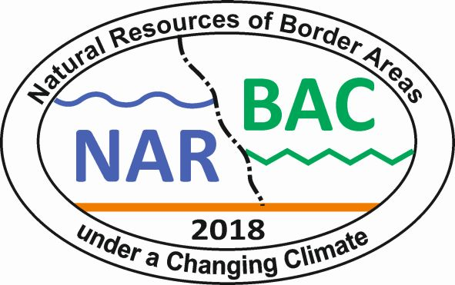
Natural resources of border areas under a changing climate

Słupsk, 25th – 28th of September, 2018

Registration form

.......................................................................................................................................................
name and surname

.......................................................................................................................................................
degree and academic title

.......................................................................................................................................................
affiliated organisation

…………………………………………………………………………………………………...
address for correspondence

phone: .............................. .........................., e-mail: .................................................................
business home

Proposal for the presentation types:

1. □ presentation (15 minutes) 2. □ poster 3. □ short presentation (10 minutes)
4. □ without presentation

Title of presentation:

.......................................................................................................................................................

.......................................................................................................................................................

.......................................................................................................................................................

................................................................................
Date and signature

